McArthur Nursery School

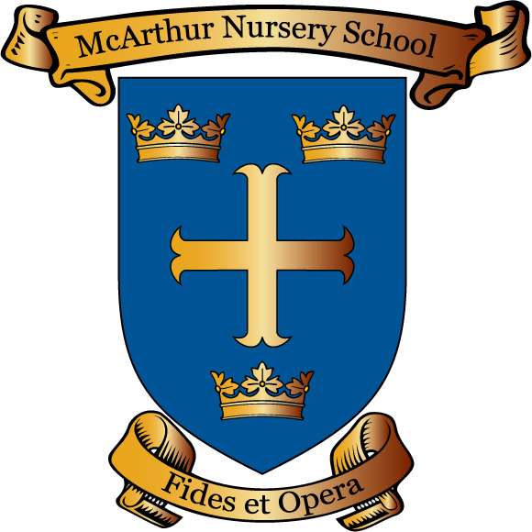

Parent/Guardian Code of Conduct Policy

Reviewed June 2022 by N Compton Review Date June 2023

Signed Chairperson Board of Governor _______________________

Date _______________________
McArthur Nursery school
Parent/Guardian & Carers School Code of Conduct
Working with Parents for Our Children

- In McArthur nursery school we value the working partnership between Home and School. We encourage good, clear and early communication. There may be opportunities in the morning supervision period, from 8.30am, for Parent/Guardians and Carers to talk briefly to their child’s teacher about any minor issues that may have come up overnight. Some examples of this type of communication may be to let the class teacher know about an illness, a simple problem with home learning or a change in traditional home-time collection arrangements. This early communication is much appreciated by the School.

- Parents may also send messages on our parent app Class Dojo. This app is however, not manned continuously.

- But it must be stressed that such morning contact or written contact via the app with School Teaching Staff is not guaranteed. In addition this short morning period is not a good time to discuss a difficult or emotionally charged problem. Instead any such important issue of communication will require an appointment to be made to speak to the Class Teacher or Principal via the School Office. We would appreciate parental support in these arrangements.

- McArthur Nursery School Staff are committed to resolving difficulties in a constructive manner, through an open and positive dialogue. However we understand that everyday misunderstandings can cause frustrations and have a negative impact on our relationships. Where issues arise or misconceptions take place, please contact your Child’s Class Teacher or the Principal who will arrange an appointment to be available to meet with you and go through the issue and hopefully resolve it to the mutual satisfaction of all stakeholders.

- It should go without saying, but just to be absolutely clear: We are a Nursery School working with young children. We deal with a huge range of issues on a daily basis and we appreciate that at times emotions can run high. However, we all deserve to be treated with respect. The McArthur Nursery School Parent/Guardian & Carers Code of Conduct Policy will rely on co-operation from everyone for it to be effective.

Please note that the following types of behaviour will not be tolerated in our School:

- Disruptive behaviour which interferes or threatens to interfere with any of the schools normal operation or activities anywhere on the school premises.
- Any inappropriate behaviour on the school premises.
- Using loud or offensive language or displaying temper.
- Verbal abuse towards or threatening in any way, a member of staff, visitor, fellow parent/carer or child.
- Damaging or destroying school property.
- Sending abusive or threatening emails or text/voicemail/phone messages or other written communications (including social media) to anyone within the school community.
- Defamatory, offensive or derogatory comments regarding the school or any of the pupils/parents/staff/governors at the school on social media (e.g Facebook)
- The use of physical, verbal or written aggression towards another adult or child. This includes physical punishment of your own child on school premises.
- Approaching someone else’s child in order to discuss or chastise them because of the perceived actions of this child towards their own child. (Such an approach to a child may be seen to be an assault on that child and may have legal consequences)
- Smoking, taking illegal drugs or the consumption of alcohol on school premises.

Should any of the above occur on school premises or in connection with school, the Board of Governors of McArthur Nursery School may feel it is necessary to take action by contacting the appropriate authorities to organise procedures to restrict the access of the offending adult to school premises.

As parental attitudes to school and the teacher can directly influence the child it is important that all exchanges between School and Home should be informed with a mutual respect for each others knowledge and concern for the pupil’s welfare. We would like to thank all Parent/Guardians & Carers in advance for abiding by this Code of Conduct in our school. It is important for Parent/Guardians and Carers to make sure any persons collecting their child/children from our School are aware of this Code of Conduct.

