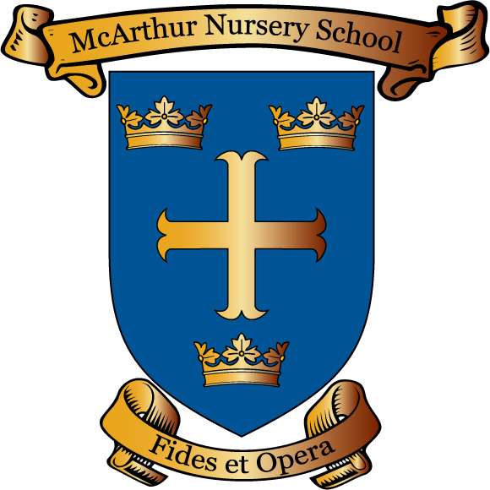
McArthur Nursery School
Susan Street
Belfast
BT5 4FE

Principal Mrs Naomi.Compton

Telephone Number 02890 451965
Email mcarthurnurseryschool@hotmail.com

Dear Parents,

Ref: Class Dojo
The rolling out of the use of Class Dojo has been proving very successful. This is a great way for us to keep parents informed about what their children are doing in school. As with the introduction of all initiatives, there are a few things which we need to work through.
Please note:
- The primary purpose of Class Dojo in our nursery school is as a reward system which keeps parents informed;
- Teachers will uploads photographs and news within their working day where possible. There is no guarantee that your child will have daily pictures or news as I am sure you will understand teachers have other commitments throughout the day

• Those teachers who are opting to use the messaging service will only respond between
8:45am – 2:30pm. There is no guarantee that a response will be made the same day a message is sent as teachers’ timetables/duties extend beyond core class teaching;
• No urgent/important communication should be sent through Class Dojo;
• Class Dojo will not be used as a means to communicate through the school office. Contact should continue to be made by phone call or in person at the reception. No responses will be made to messages received through Class Dojo;
• And finally in the unlikely event that a parent misuses Class Dojo please be aware that their account will be permanently deleted. This includes the posting of inappropriate or malicious comments and/or using the messaging service in an inappropriate way.
Thank you for your support in making the introduction of Class Dojo a success; the children have been greatly motivated and we are receiving positive feedback from parents.
Yours Sincerely

N. Compton
Principal

