McArthur Nursery School
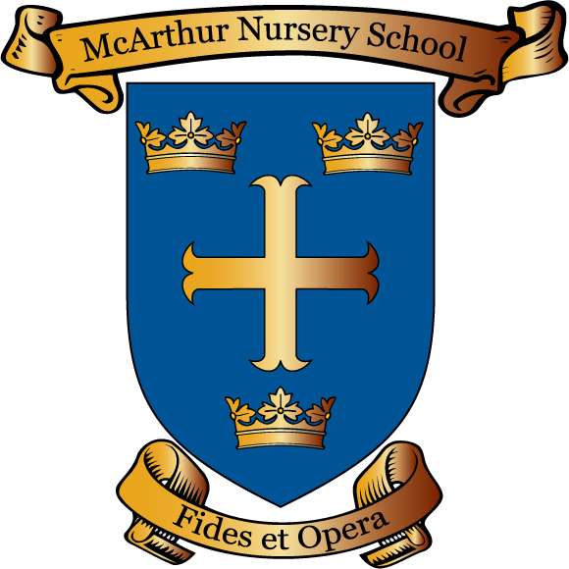

After School
Policy

Reviewed September 2023 by N Compton
Review Date September 2024

Signed Chairperson Board of Governor _______________________

Date _______________________
After School Policy

Our afterschool sessions will run from 13th November, 2023 until June 20th , 2024,, 1-2pm, on set dates, Monday-Thursday. These sessions will be run by an external provider, Luke Liporis Sportstopia Ltd. Spaces will be allocated on a first come first served spaces and are limited to 8 children.

In line with our school settling in policy, staff will inform you if and when we feel your child is ready and able to stay for this extended more structured period of school. It is important to remember that the sessions are at a time of day when children are already very tired and an extra hour in school may not suit every child.

Payments and bookings of sessions will be processed through Sportstopia Ltd, School will not be involved with bookings or payments at any stage. No money can be received by school for the after school activity. If Sportstopia staff have to cancel a session, for example due to staff illness, they will contact parents and no alternative provision will be available.

Snack will not be provided but parents are welcome to send in a healthy snack in a named container, no nuts. Water will be provided if the children require it.

All communication with regards the sessions , attendance or any issues should be directed to Sportstopia directly. School staff will not be able to pass on messages or answer queries with regards the after school sessions.

