CHILD PROTECTION
WHO DO I SPEAK TO?
Designated Officer - Mrs Naomi Compton
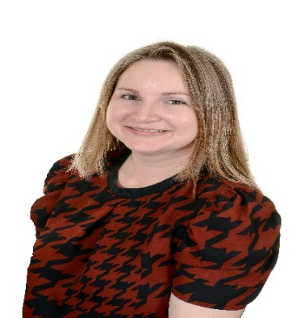

Deputy Designated Officers
Miss Elizabeth Flemming Ms Emma Mathison
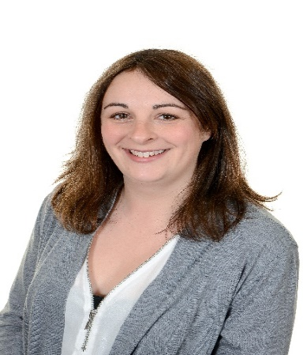
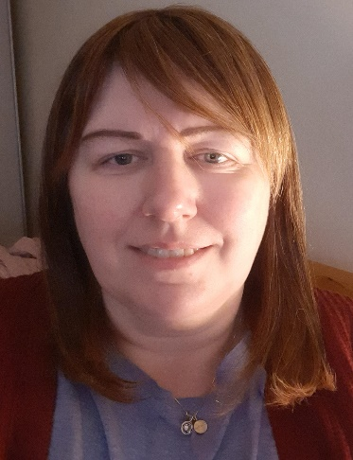

Board of Governors Officers
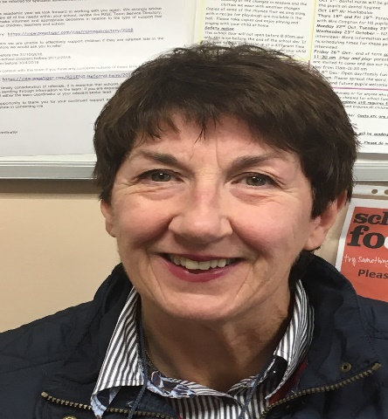
Ms Anne Millar Mr Neville Thomson

