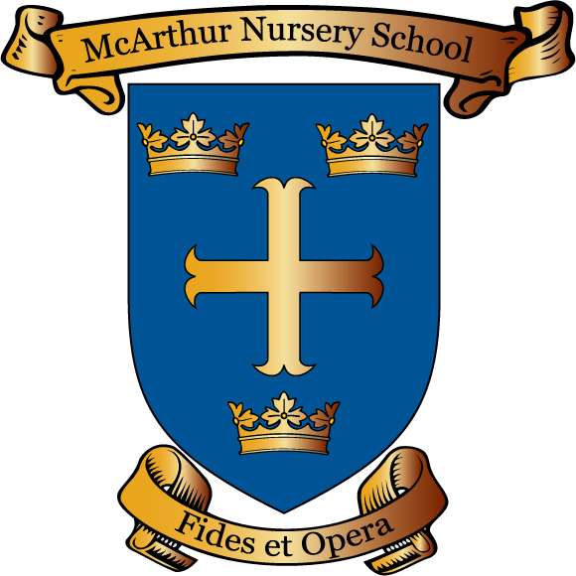
Please email mcarthurnurseryschool@hotmail.com to request a copy of this policy.

